Application of ODE Solvers to Dynamical Problems

1. Problem definition and analytic solution

(1-1) ODE Problem and exact solution (see Appendix for ODE solvers)

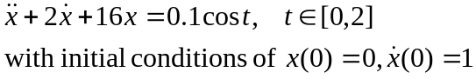

Exact Solution

(1-2) Standard ODE formulation: The 1st order system of ODE
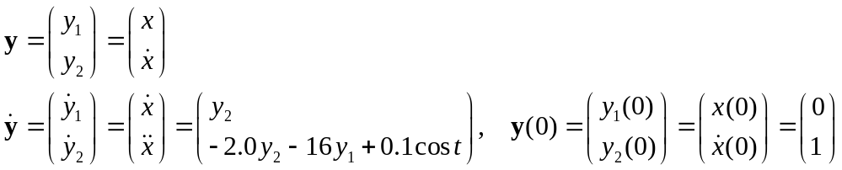

(1-3) Program for the system dynamics

%-------------------------------------------------------------------------
function [dot_y] = ODE_System1_B_Dynamics(y,t)
%-------------------------------------------------------------------------
y1 = y(1) ;
y2 = y(2) ;
%-------------------------------------------------------------------------
a0 = 16.0 ;
a1 = 2.0 ;
%
force =0.1*cos(t) ;
%-------------------------------------------------------------------------
dot_y(1) = y(2) ;
dot_y(2) = force - a0*y1 - a1*y2 ;
%-------------------------------------------------------------------------

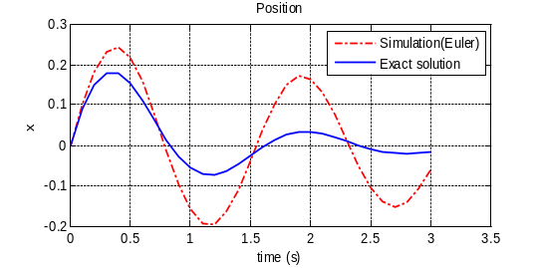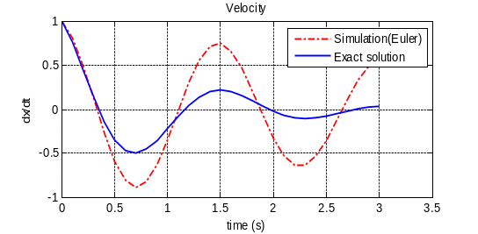

2. Rain drop motion in the vertical direction
(2-1) Motion Equations

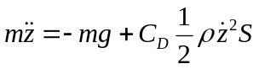 With 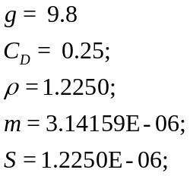
Initial height = 500 m
Time=[0,20]

(2-2) Program for the system dynamics
%------------------------------------------------------------------------
function [dot_y] = ODE_System2_B_Dynamics(y,t)
%-------------------------------------------------------------------------
y1 = y(1) ;
y2 = y(2) ;
%-------------------------------------------------------------------------
g0 = 9.8 ;
CD = 0.25 ;
rho=1.2250 ;
m=3.14159E-06 ;
S=1.2250E-06 ;
%-------------------------------------------------------------------------
dot_y(1) = y(2) ;
dot_y(2) = 0.5*CD*rho*S*y2^2/m - g0 ;
%-------------------------------------------------------------------------

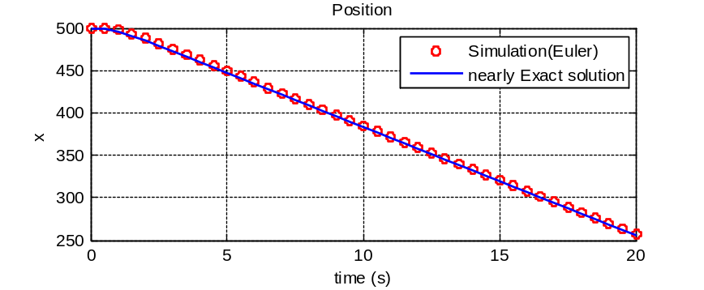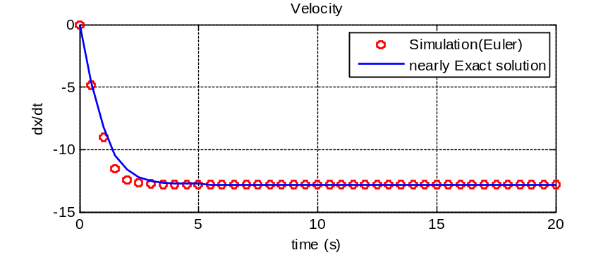
3. Spring-Mass-Damper system
(3-1) System dynamics
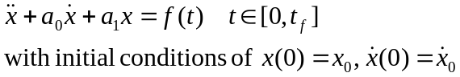
(3-2) Representation in the first order system of ODEs
Let’s define new state variable
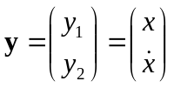
Then, the equation (1) can be written as
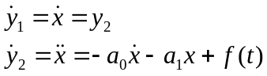
→ 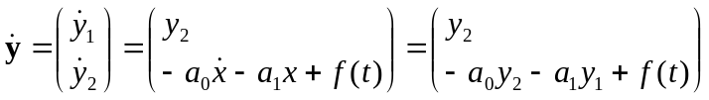 (2)
With initial conditions of 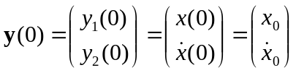 (3)
(3-3) Program for cosine foce

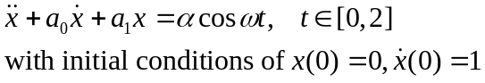

(3-4) Program for the system dynamics

%-------------------------------------------------------------------------
function [dot_y] = ODE_System3_B_Dynamics(y,t)
%-------------------------------------------------------------------------
y1 = y(1) ;
y2 = y(2) ;
%-------------------------------------------------------------------------
a0 = 2.0 ;
a1 = 2.0 ;
%------------------------------------------------------------------------
alpa = 0.50;
omega= 1.00;
%
force = alpa*cos(omega*t) ;% force=f(t) should be defined
%------------------------------------------------------------------------
dot_y(1) = y(2) ;
dot_y(2) = force - a0*y1 - a1*y2;
%-------------------------------------------------------------------------

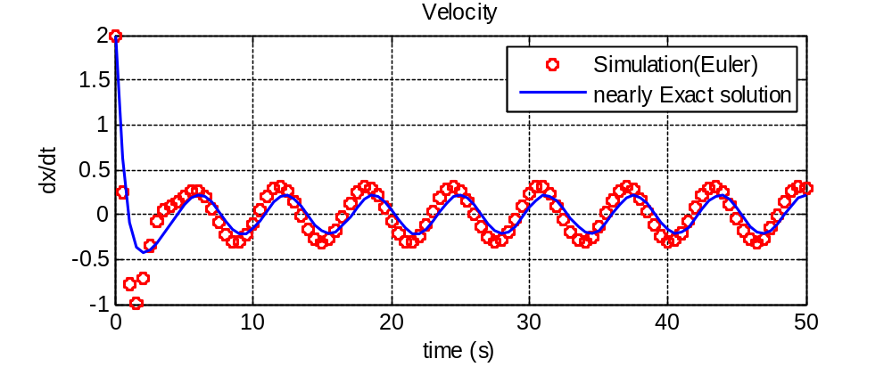
4. Pendulum motion under aerodynamic drag

(a point mass hanged with a mass-less string)

(4-1) Motion Equations
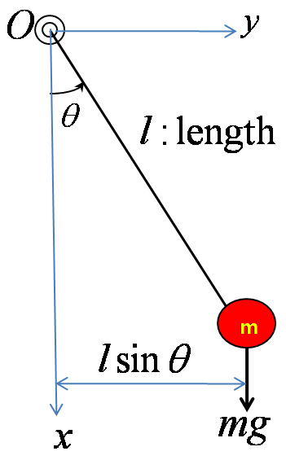
- Center of motion: O
- Motion can be fully described by the angular displacement
- motion equation, moment of inertia, and net external moment
around the center of rotation
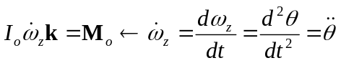
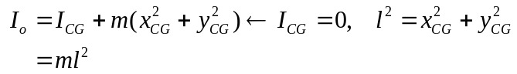

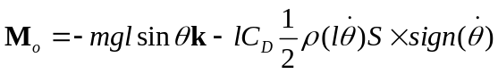
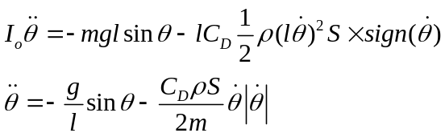

With the following data
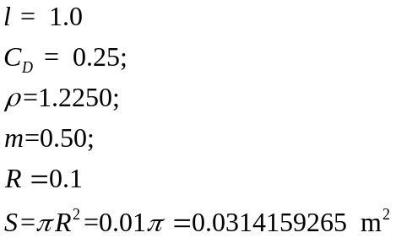 and 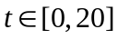

Initial condition and 1st order ODE form

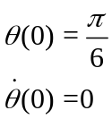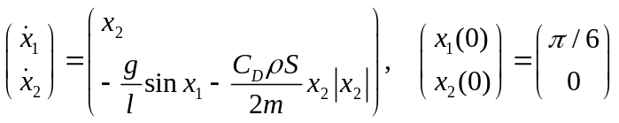

(4-2) Program for the system dynamics

%-------------------------------------------------------------------------
function [dot_y] = ODE_System4_B_Dynamics(y,t)
%-------------------------------------------------------------------------
theta = y(1) ; % angle
dtheta = y(2) ; % angular velocity
%-------------------------------------------------------------------------
Length = 1.0 ;
CD = 0.50 ;
Density = 1.2250 ;
Mass = 0.25 ;
Radius = 0.1 ;
GravCoef= 9.8 ;
Area = pi*Radius^2 ;
%
Coef1 = -GravCoef/Length ;
Coef2 = -CD*Density*Area*0.5 ;
%------------------------------------------------------------------------
alpa = 0.50;
omega= 1.00;
%
force = alpa*cos(omega*t) ;% force=f(t) should be defined
%------------------------------------------------------------------------
dot_y(1) = dtheta ;
dot_y(2) = Coef1*sin(theta) + Coef2*dtheta*abs(dtheta) ;
%-------------------------------------------------------------------------

Euler Method
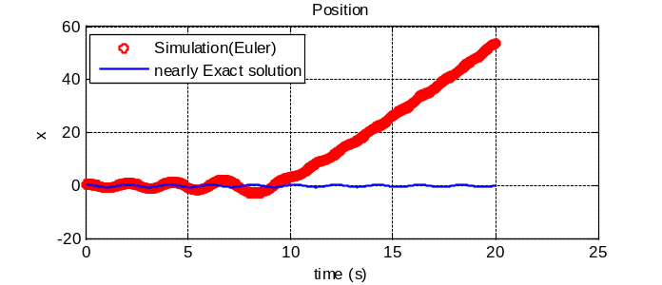
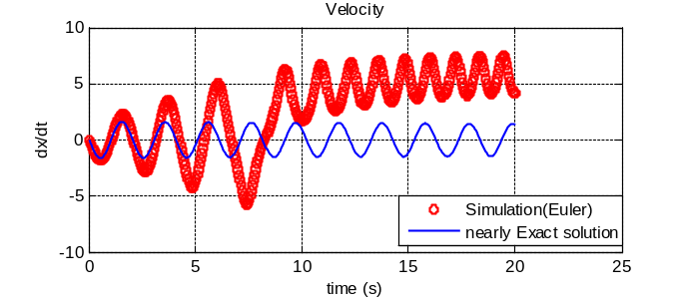
Heun’s Method

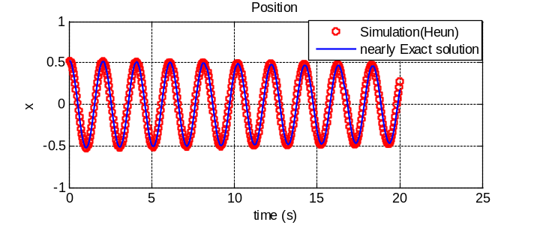
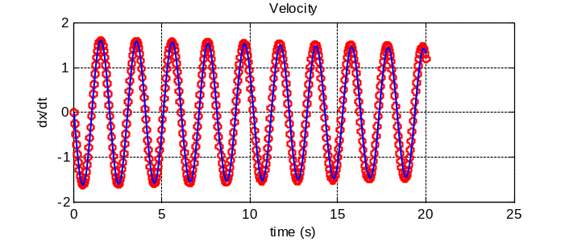
5. Double-Pendulum motion under aerodynamic drag

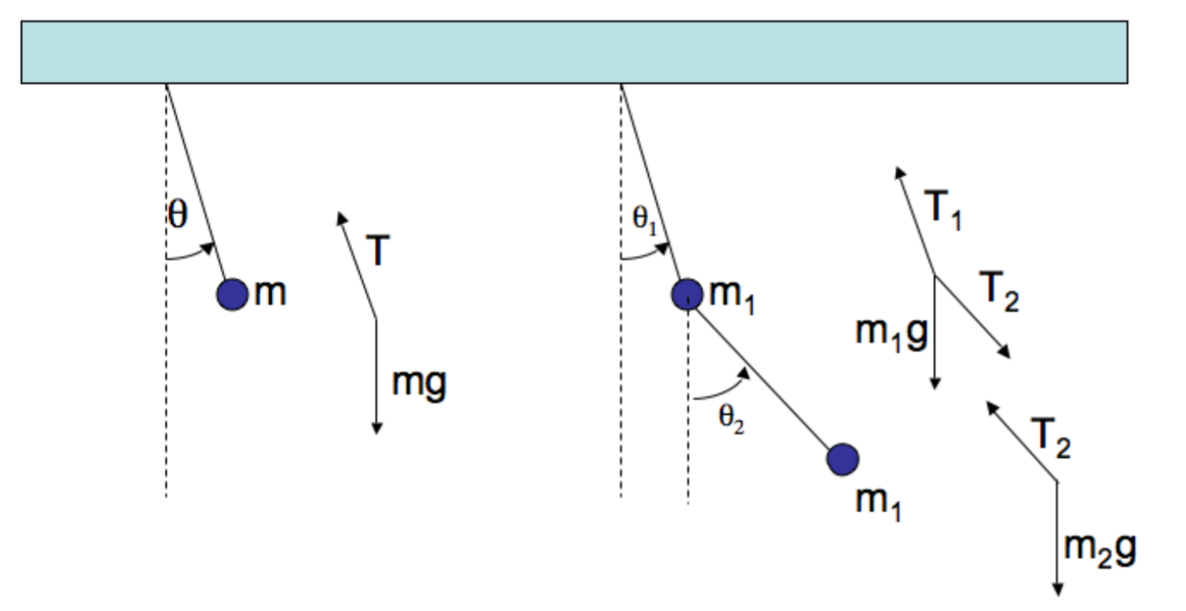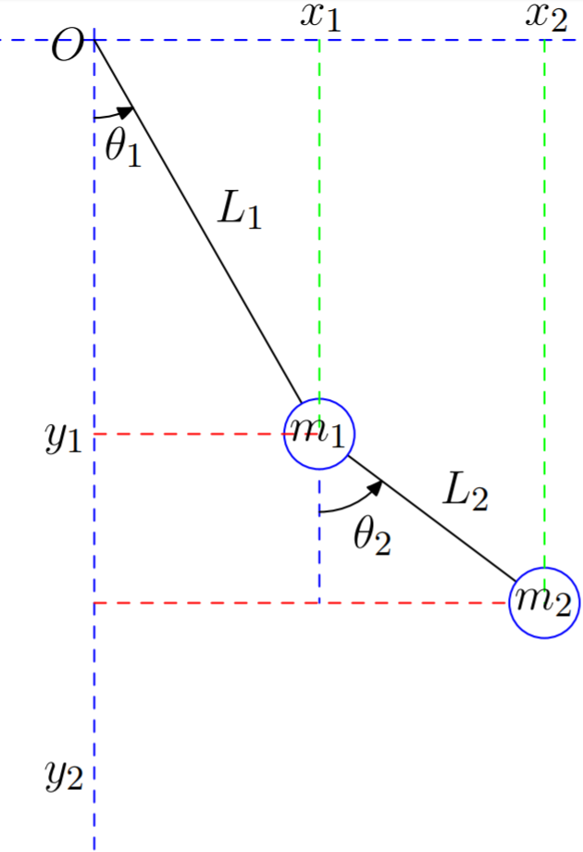

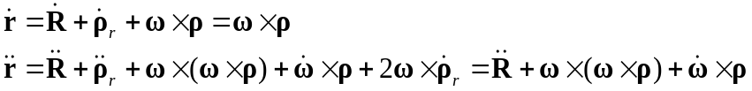

(5-1) Derivation of motion equation
- Inertial velocity and acceleration of mass 1
Condition for mass 1
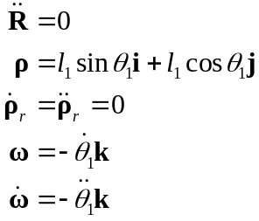

Inertial velocity

Inertial accelerations
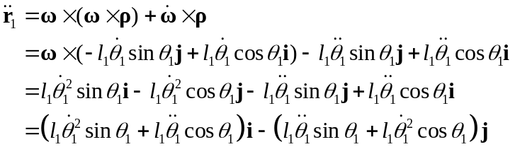

(b) Inertial acceleration of mass 2
Condition for mass 2
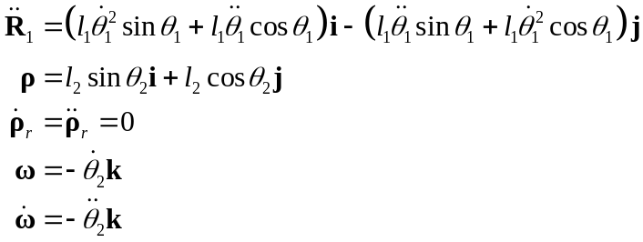
Inertial accelerations
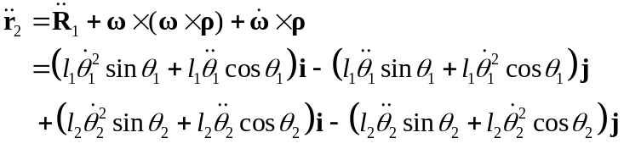

(c) External and Inertial forces acting on each mass
Mass 1 : 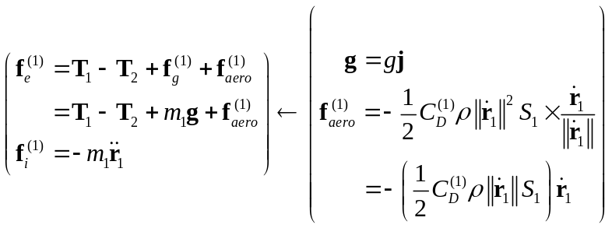
Mass 2: 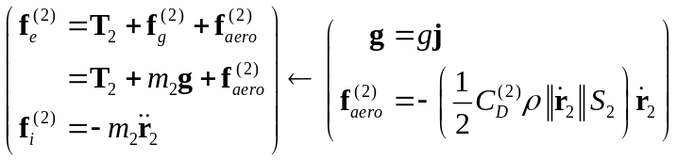

(d) Force and Moment equilibrium at the rotation hinge of each mass
Mass 1 :
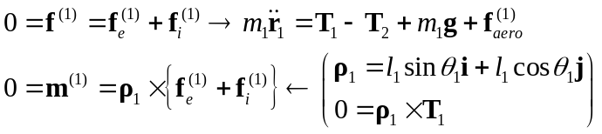
Mass 2:
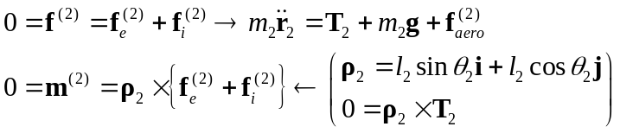

(e) Equations of motion
Mass 1 :
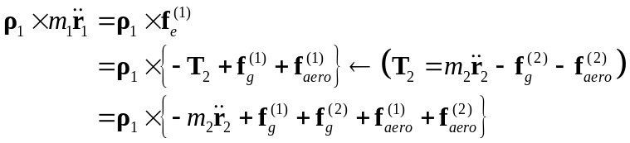
Mass 2:
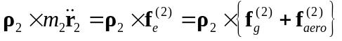
Expansion of the left-hand-side terms
Using
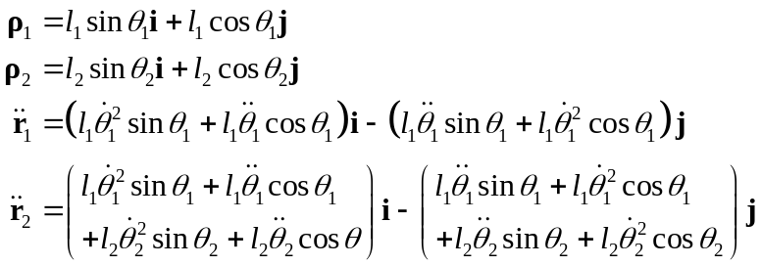

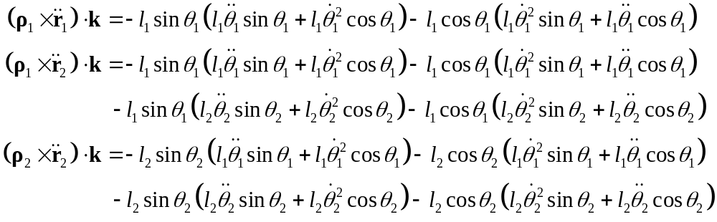
Therefore, we can get
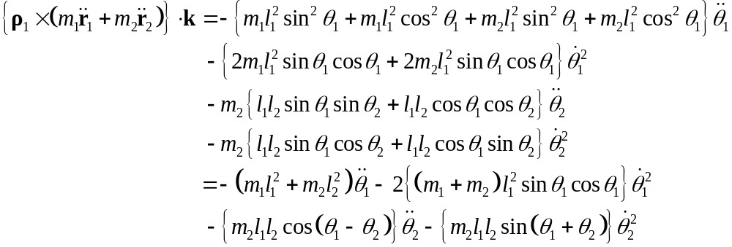
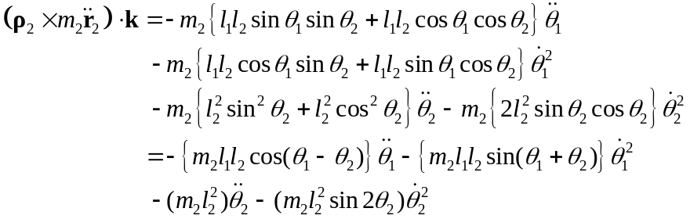
Final derivation
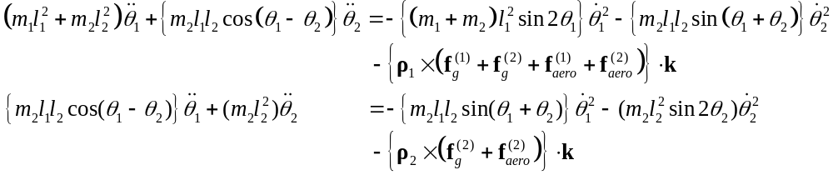
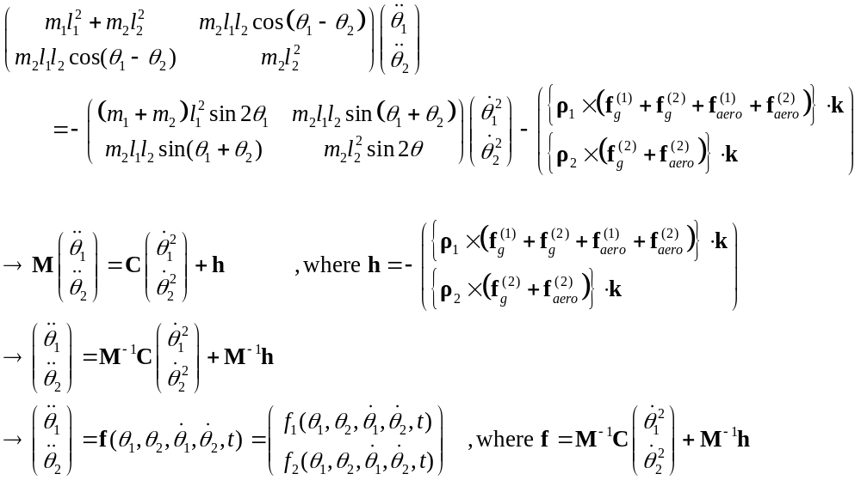

With
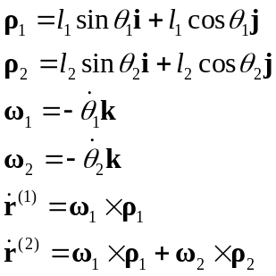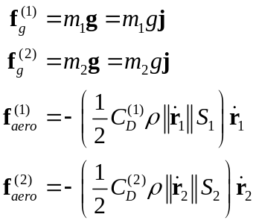

(5-2) Data and initial conditions

With the following data and initial conditions over
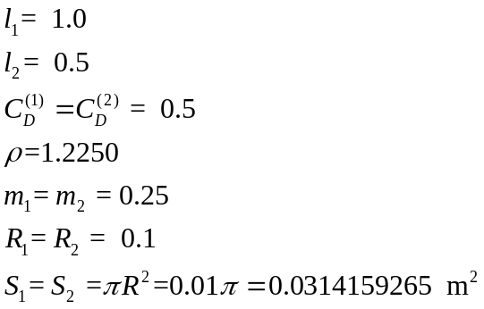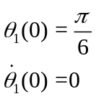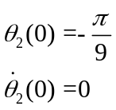

(5-3) Motion equation represented in the first order system of ODEs

Equation
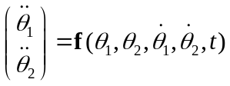
States
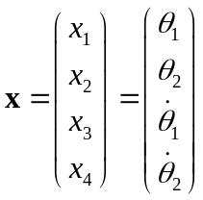 → 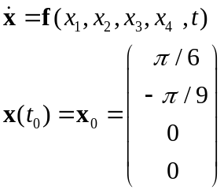
(5-4) Program for the system dynamics

%-------------------------------------------------------------------------
function [dot_y] = ODE_System5_B_Dynamics(y,t)
%-------------------------------------------------------------------------
th1 = y(1) ; % angle of mass 1
th2 = y(2) ; % angle of mass 2
dth1 = y(3) ; % angular velocity of mass 1
dth2 = y(4) ; % angular velocity of mass 2
%
cth1 = cos(th1) ; sth1 = sin(th1) ;
cth2 = cos(th2) ; sth2 = sin(th2) ;
%
dth1P2 = dth1*dth1 ;
dth2P2 = dth2*dth2 ;
%-------------------------------------------------------------------------
Density = 1.2250 ;
GravCoef = 9.8 ;
Length1 = 1.0 ; Length2 = 1.0 ;
CD1 = 0.50 ; CD2 = 0.50 ;
Mass1 = 0.25 ; Mass2 = 0.25 ;
Radius1 = 0.1 ; Radius2 = 0.1 ;
Area1 = pi*Radius1^2 ; Area2 = pi*Radius1^2 ;
%-------------------------------------------------------------------------
% (1) Displacement and velocity vectors of pendulums
%-------------------------------------------------------------------------
r1_vec(1) = Length1*sth1 ; r2_vec(1) = Length2*sth2 ;
r1_vec(2) = Length1*cth2 ; r2_vec(2) = Length2*sth2 ;
%
omega1 = -dth1 ; omega2 = -dth2 ;
%
v1_vec(1) = -omega1*r1_vec(2) ;
v1_vec(2) = omega1*r1_vec(1) ;
speed1 = sqrt( v1_vec(1)^2 + v1_vec(2)^2 ) ;
%
v2_vec(1) = v1_vec(1) - omega2*r2_vec(2) ;
v2_vec(2) = v1_vec(1) + omega2*r2_vec(1) ;
speed2 = sqrt( v2_vec(1)^2 + v2_vec(2)^2 ) ;
%
CoefA1 = -CD1*Density*Area1*0.5*speed1 ;
CoefA2 = -CD2*Density*Area2*0.5*speed2 ;
%-------------------------------------------------------------------------
% (2) M-matrix and its inverse
%-------------------------------------------------------------------------
fm11 = Mass1*Length1^2 + Mass2*Length2^2 ;
fm12 = Mass2*Length1*Length2*cos(th1 - th2) ;
fm21 = fm12 ;
fm22 = Mass2*Length2^2 ;
%
det = fm11*fm22 - fm12*fm21 ;
fm_inv(1,1) = fm22 ; fm_inv(1,2) = -fm12 ;
fm_inv(2,1) = -fm21 ; fm_inv(2,2) = fm11 ;
%
fm_inv(1:2,1:2) = fm_inv(1:2,1:2)/det ;
%-------------------------------------------------------------------------
% (3) C-matrix
%-------------------------------------------------------------------------
cm(1,1) = (Mass1 + Mass2)*sin(2.0*th1)*Length1^2 ;
cm(1,2) = Mass2*Length1*Length2*sin(th1 + th2) ;
cm(2,1) = cm(1,2) ;
cm(2,2) = Mass2*Length2^2 ;

%-------------------------------------------------------------------------
% (4) Gravity and aerodynamic forces
%-------------------------------------------------------------------------
force2(1:2) = CoefA2*v2_vec(1:2) ;
force2(2) = force2(2) + Mass2*GravCoef ;
%
force1(1:2) = CoefA1*v1_vec(1:2) + force2(1:2) ;
force1(2) = force1(2) + Mass1*GravCoef ;
%-------------------------------------------------------------------------
% (5) z-axis Components of rotational moments
%-------------------------------------------------------------------------
Moment(1) = r1_vec(1)*force1(2)-r1_vec(2)*force1(1) ;
Moment(2) = r2_vec(1)*force2(2)-r2_vec(2)*force2(1) ;
%-------------------------------------------------------------------------
% (6) Assemble Right-Hand-Side
%-------------------------------------------------------------------------
vec(1) = dth1P2 ; vec(2) = dth1P2 ;
%
Moment(1) = Moment(1) + cm(1,1)*vec(1) + cm(1,2)*vec(2) ;
Moment(2) = Moment(2) + cm(2,1)*vec(1) + cm(2,2)*vec(2) ;
%-------------------------------------------------------------------------
% (6) Motion Equations
%-------------------------------------------------------------------------
dot_y(1) = dth1 ;
dot_y(2) = dth2 ;
%
dot_y(3) = fm_inv(1,1)*Moment(1) + fm_inv(1,2)*Moment(2) ;
dot_y(4) = fm_inv(2,1)*Moment(1) + fm_inv(2,2)*Moment(2) ;
%
dot_y(3:4) = -dot_y(3:4) ;
%-------------------------------------------------------------------------

RK-4 Solution
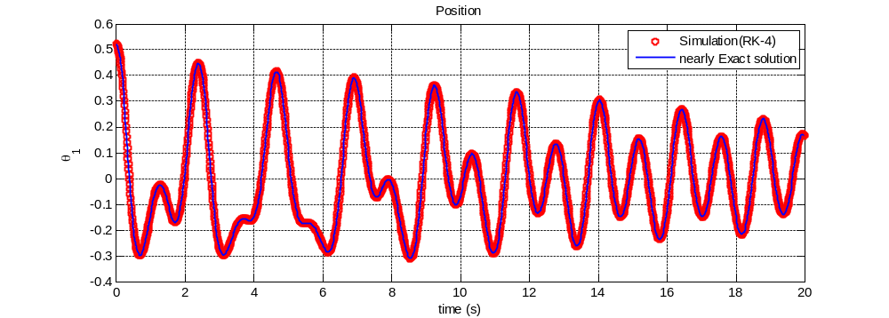
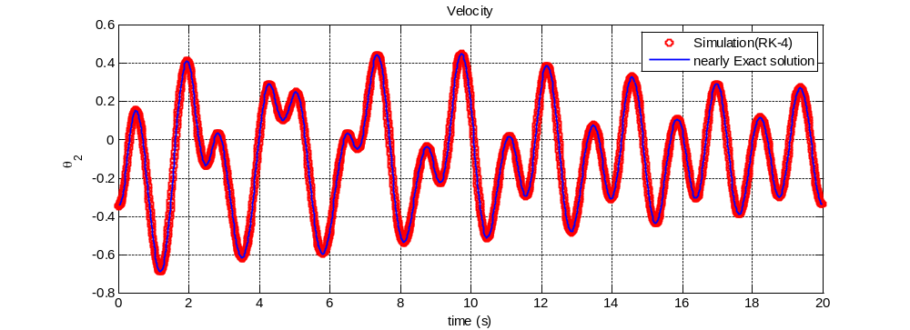
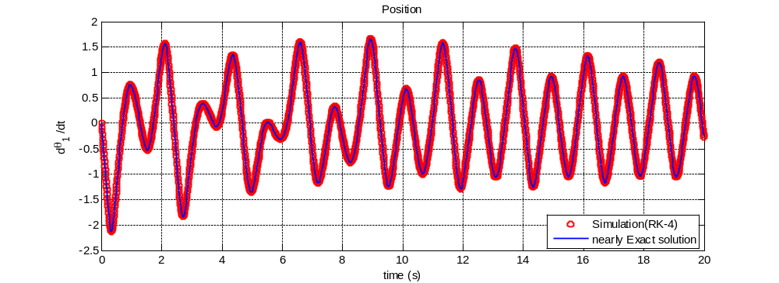
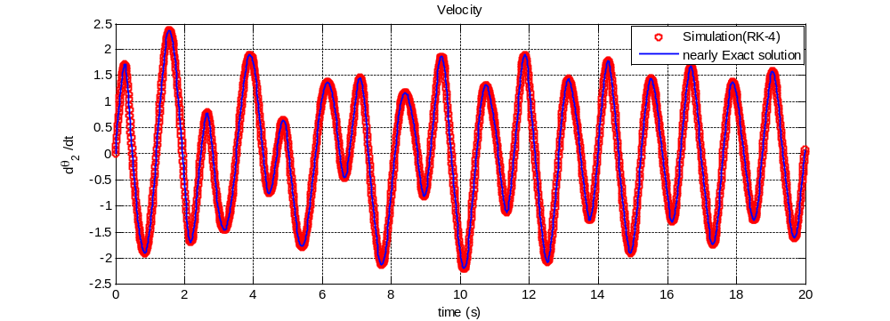
See YouTube for Simulation Examples

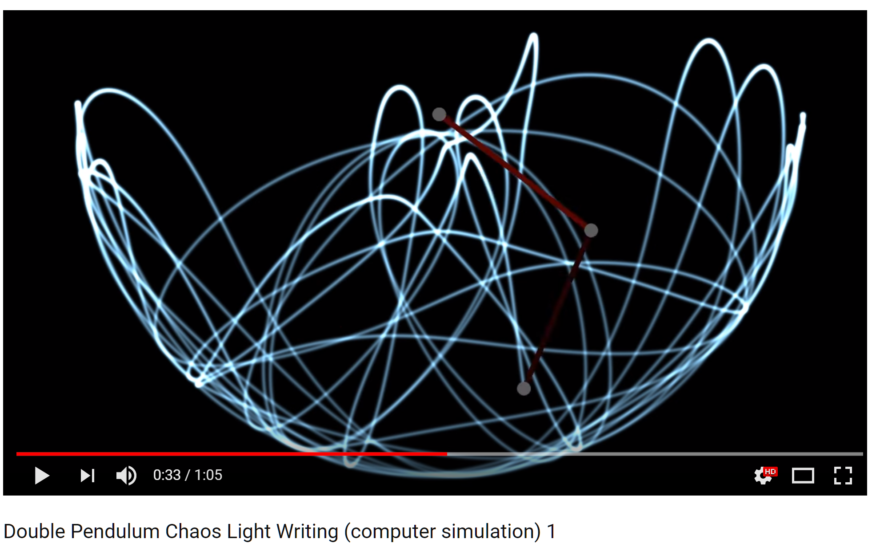

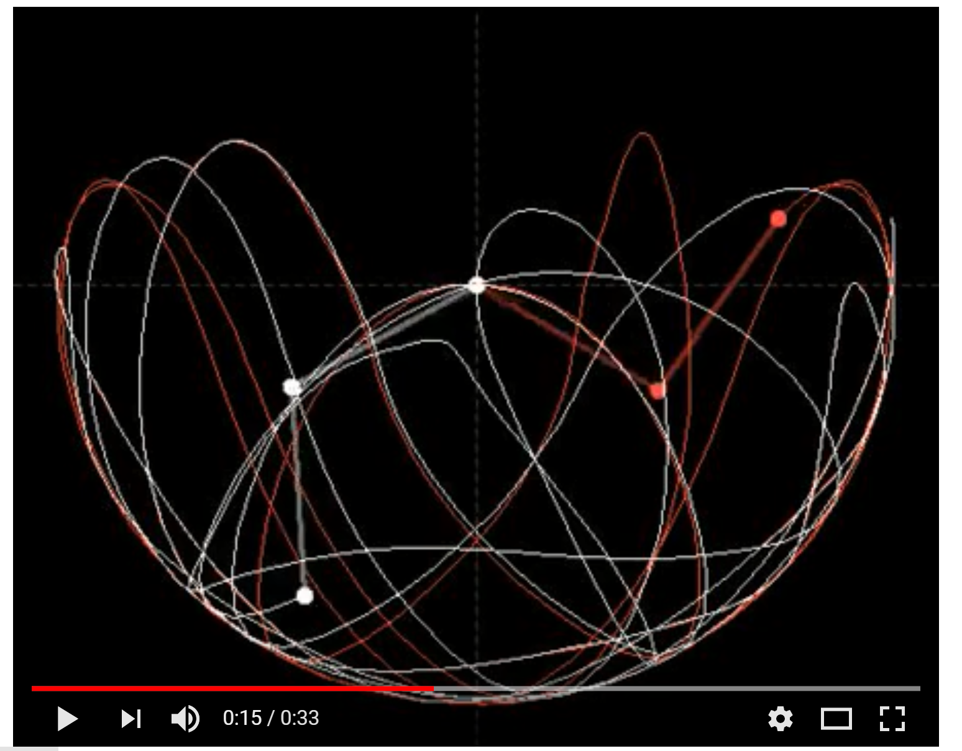
Appendix: ODE solvers (Numerical Time Integration Algorithm)

Problem statement

A-1. Euler method

A-2. Heun’s predictor-corrector algorithm

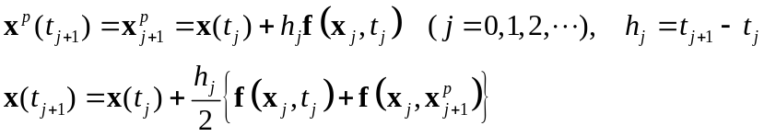

A-3. 3rd order Runge-Kutta method (RK-3)

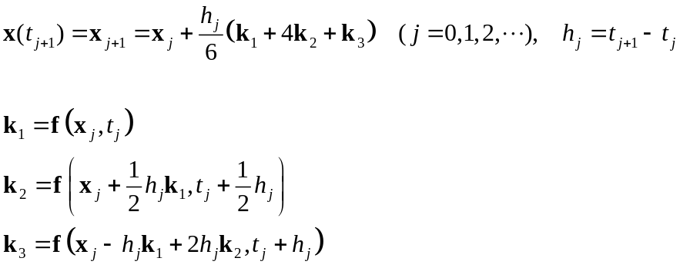

A-4. 4th order Runge-Kutta method (RK-4)

